**Minor project-2 Synopsis Topic**

**Smart Irrigation System**



**Project Supervisor:**

**Ms. Monika**

**Submitted to:**

**Dr. Juhi Gupta**

**Group Member:**

**Divya Singh 20102019**

**ABSTRACT:**

The automatic plant monitoring system has recently attracted tremendous interest due to the potential application in emerging technology. More importantly, this technique is used to enhance the performance of existing techniques or to develop and design new techniques for the growth of plants. The plant monitoring system is helpful for watering the plants and to monitor few parameters for growth of plants. This system is very used in few areas like nursery farms and in agriculture. In this system a mechanism is established to find the moisture content in the soil with the help of soil moisture sensor and depending upon the condition of the sensor the water is controlled. Another important parameter is by capturing the images of the plant by using Arduino interfaced camera, and processing the image by using image processing to analyze and determine the disease effected by creating the feature vector database and retrieval of images from database similar to query image. This helps in providing the appropriate amount of water for plants so reduces some situations like mud cracks, water logging. This helps in irrigating the field even during night time, so does not require the farmer to switch ON the motor manually.

**INTRODUCTION:**

The Internet of Things (IoT) is the network of interconnected sensor-equipped electronic devices that collect data, communicate with each other, and can be monitored or controlled remotely over the Internet. The main goal of the IoTs development is extends the limit of internet connectivity from digital devices to physical objects. It enables the communication between digital devices, objects and other systems. The Smart Irrigation System is an IoT based device which is capable of automating the irrigation process by analyzing the moisture of soil and the climate condition (like raining). It provide water supply at the right time, in right quantity and at the right place in field which plays a vital role in the plants growth. Water management remotely is also challenging task, especially the management becomes more difficult during the shortage of water, which may otherwise damage the crop. By using sensors like moisture, rain, etc. water supply for irrigation can be managed easily by analyzing the condition of soil and climate. Soil moisture sensors smartly measure the soil moisture and based on that data, field is get irrigated automatically with less human interventions. The complete data of moisture is accessible to the farmers at distance on the mobile in a graphical form.

**PROPOSED SYSTEM:**

* Initially we have to collect the analog output value from the soil moisture sensors.
* And we have to fix a particular threshold value for particular sensors.
* If the output analog value is greater than the threshold value, then it indicates that the soil is dry condition.
* So we have to switch on the water motor. The water motor is used to pump water to dry sectors to make them wet by using relay, which will be acting as the switch.
* Water is pumped into the dairy sector until entire soil will be becoming wet. After a particular time the dry soil becomes wet.
* If the output of the soil moisture sensor is less than the prescribed threshold values it indicates the soil is wet condition. So that water motor will come into switched off.

**FLOW CHART:**

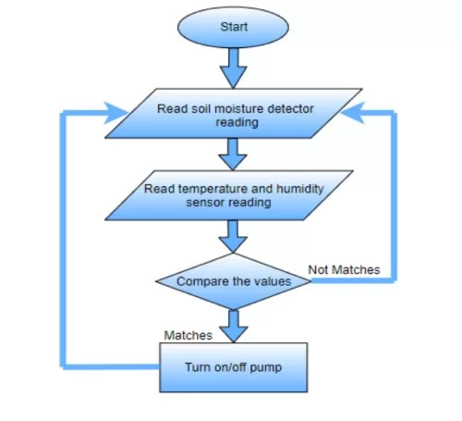

**CONCLUSION:**

* By implementing the proposed system there are various benefits for the government and the farmers. For the government a solution for energy crisis is proposed. By using the automatic irrigation system it optimizes the usage of water by reducing wastage and reduce the human intervention for farmers.
* To further enhance the daily pumping rates tracking arrays can be implemented. This This system demonstrates the feasibility and application of using solar PV to provide energy for the pumping requirements for sprinkler irrigation. Even though there is a high capital investment required for this system to be implemented, the overall benefits are high and in long run this system is economical.

**REFERENCE:**

1. https://ieeexplore.ieee.org/document/8300802

2. https://www.loveyourlandscape.org/expert-advice/water-smart-landscaping/smart- irrigation/shopping -for-a-smart-irrigation-system/

3. https://www.epa.gov/watersense/weather-based-irrigation-controllers

4. https://circuitdigest.com/microcontroller-projects/iot-based-smart-irrigation-system-using-esp8266-an d-soil-moisture-sensor 5.https://www.google.com/search?q=SOIL+MOISTURE+SENSOR:&rlz=1C1RXQR_enIN988IN988&source =lnms&tbm=isch&sa=X&ved=2ahUKEwjpkq7Rs9D6AhXUTmwGHW3KD38Q_AUoAXoECAEQAw&biw=1 536&bih=722&dpr=1.25#imgrc=cH7Enh6tRXjuNM

5. https://circuitdigest.com/microcontroller-projects/iot-based-smart-irrigation-system-using-esp8266-an d-soil-moisture-sensor 1